 **OOAD Lab Project Proposal**

**Submitted to:**

**Dr. Awais**

**Submitted by:**

**2016-CS-122 Hamza Farooq**

**2016-CS-105 Muhammad Haris Khan**

**2016-CS-178 Komal Shehzadi**

# 

Contents

Or Sunao 3

➢ Vision: 3

➢ High Level User Story 3

Admin 3

User 3

➢ Low Level User Story 4

Admin 4

User 4

➢ Use Cases 5

o Use Case UC1: Process Registration Approval 5

o Use Case UC2: Process of Viewing User Records 6

o Use Case UC3: Process Update Record 7

o Use Case UC4: Process Registration 8

o Use Case UC5: Process Log in 9

o Use Case UC6: Send and Receive Text Message 11

o Use Case UC7: Send and Receive Audio Message 12

o Use Case UC8: Send and Receive Images 14

➢ Use Case Diagram 16

➢ System Flow Diagram 18

➢ Wire Frames of System 19

➢ Domain Model 25

➢ Back Locks: 26

o Weakness in security: 26

o Weakness in connection: 26

➢ Sprint Plan: 26

➢ Development story: 26

# Or Sunao

## Vision:

In this project we are implementing a source of communication, a chat box named “Or Sunao”. In further discussion we will call that project by its name from which you are obviously familiar. This is the most common word in text messages and calls in our country. So the main idea of this project is to make people speak out what they want. This app has a community who can interact with each other by using this app so the people around the globe can connect to each other. This app will have a lot of features which will be explained further on. This will connect all the users entered in “Or Sunao”.

## High Level User Story

### Admin

As an Admin

1. I want to approve the valid credentials for registration of user on remote server.
2. I want to view the record of all registered users.
3. I want to update, Suspend or delete the user account.

### User

As a User

1. I want to register on the server easily and successfully.
2. I want to login to my registered account securely.
3. I want to send and receive text to or from another user.
4. I want to send and receive images to or from another user.
5. I want to record audio using my device.
6. I want to send and receive audio to or from another user.

## Low Level User Story

### Admin

As an Admin

1. I cannot change users valid credentials until user itself update it.
2. I cannot log in to user accounts.
3. I cannot see any user’s messages.
4. I cannot see any of the shared contents between users.
5. I cannot send any messages from any user’s account.
6. I cannot delete any messages from user’s account.

### User

As a User

1. I cannot log in to any other account other than my own account.
2. I cannot view other user’s chat.
3. I cannot view any media of other user’s chat.
4. I cannot approve registration requests.
5. I cannot delete or suspend any account.

## Use Cases

### Use Case UC1: Process Registration Approval

Description: This use case describes the approval of registration requests from users.

Primary Actor: Admin

#### Stakeholders and Interests:

* Admin: Wants to approve user’s request for registration.
* Company: Wants to satisfy user interests.

Preconditions: User must register an account.

#### Success Guarantee (Post Conditions):

* After approval a message will be displayed on screen that ‘User is successfully registered.

#### Basic flow:

* User opens the app, and move to registration form to enter the chat box and enter his credentials to register.
* Admin will check the validity of credentials and complete information required and then approves the registration request.
* If the account is valid user enters the chat box and a welcome message will be displayed.
* Now user can connect to other users over there.

#### Extensions (Alternate Flow):

* If the user credentials are invalid or not according to requirement then admin will notify him/her.

### Use Case UC2: Process of Viewing User Records

Description: This use case describes how the admin can see all of the user’s record.

Primary Actor: Admin

#### Stakeholders and Interests:

* Admin: Wants to see the list of all the registered users and manage the users.

Preconditions: There must be at least one user that should be registered.

#### Success Guarantee (Post Conditions):

* After the selection of ‘view record’ option admin will see the screen displaying all the users.
* Admin can select any user and see its credentials and other information given.

#### Basic flow:

* Admin opens the app from admin account or server and click on the ‘view record’ or ‘all users’ link or button.
* A list of all the users, name and picture will be displayed.
* Now admin click on any of the names and see the details of the particular user.

### Use Case UC3: Process Update Record

Description: This use case describes how the admin can update, delete or suspend the user account/details/record.

Primary Actor: Admin

#### Stakeholders and Interests:

* Admin: Wants to update or suspend or permanently delete the account of a registered user depending upon its negative use.
* Company: Wants to satisfy user interests and protection of the data and all the private information.

Preconditions: User must have a registered account to update, suspend or delete the account by admin/server.

#### Success Guarantee (Post Conditions):

* If the account is updated a message will be displayed to both admin and user that ‘Account successfully updated.’
* If the account is suspended the user will see the notification about the account suspended.
* If account is deleted permanently the user will be notified if he/she tries to login from that account again.

#### Basic flow:

* Admin enters the app from the administrator account or server.
* Admin updates the user’s account information.
* Admin may suspend the account or delete it permanently if it is misused.
* User will also be notified about the update suspension or deletion of account.

#### Extensions (Alternate Flow):

1. If the user gives an identity proof or any authentic proof then user can get his account unblocked.

### Use Case UC4: Process Registration

Description: This use case describes how the user can register using some credentials on chat box.

Primary Actor: User, Admin

#### Stakeholders and Interests:

* User: Wants user-friendly interface and wants to register easily.

* Admin: Wants to authorize user to register account.
* Company: Wants to satisfy user interests.

Preconditions: User must have internet connection.

#### Success Guarantee (Post Conditions):

* Registration screen displays some text boxes to enter his/her credentials.

#### Basic flow:

* User opens the app, and move to registration form to register the account.
* The constraints of the entered information will be checked and told to user if invalid.
* After entering the information user will click the register button and the request will be sent to admin.

Now admin will approve the request after checking the details and then user can connect to other users over there

### 

### Use Case UC5: Process Log in

Description: This use case describes how the user can log in using some credentials on “Or Sunao”.

Primary Actor: User

#### Stakeholders and Interests:

* User: Wants user-friendly interface and wants to log in easily.

* Admin: Wants to authorize user to log in “Or Sunao” every time he wants.
* Company: Wants to satisfy user interests.

Preconditions: User must have a registered account.

#### Success Guarantee (Post Conditions):

* ‘Log in Screen’ displays chat box log in screen so that the user can log in on chat box.
* ‘Welcome Screen’ will be shown when user log in on chat box.
* ‘Or Sunao Screen’ will be displayed now and user can connect to any user now.

#### Basic flow:

* User opens the app, and move to log in form to enter the “Or Sunao” and enter his credentials in log in page.
* The validity of account will be checked and the appropriate message will be displayed if it is invalid.
* If the account is valid user enters the chat box and a welcome message will be displayed.
* Now user can connect to other users over there.

#### Extensions (Alternate Flow):

1. If the user log in wrong multiple times Admin can block his access and take him back to the registration page.
2. If the password is wrong admin can notify her/him.

### Use Case UC6: Send and Receive Text Message

Description: This use case describes how the user can send and receive text messages in “Or Sunao”.

Primary Actor: User_1 (Sender), User_2 (Receiver)

#### Stakeholders and Interests:

* User_1 (Sender): Wants user-friendly interface and wants to send text messages easily and efficiently.

* User_2 (Receiver): Wants user friendly environment and wants to receive text messages easily from the sender.
* Company: Wants to satisfy user interests.

Preconditions:

* User must have log in on “Or Sunao”.
* Users must have a stable online connection to communicate with each other.

#### Success Guarantee (Post Conditions):

* When user log in all the log in contacts will be shown and now user can connect to any user by just clicking on his/her profile.
* Then a chat box screen must be shown so the user can send and receive text messages.

#### Basic flow:

* log in “Or Sunao”.
* A screen will appear in which all the log in users profiles will appear.
* Select the user with whom user wants to connect by just clicking on his/ her profile.
* If user is not blocked by the person a chat box screen will appear otherwise he will be notified that he is blocked by the user.
* Now chat box screen will appear on which user can send and receive text by using text box and “Send” button

#### Extensions (Alternate Flow):

* If the user account is reported multiple times Admin can block his account permanently.

### Use Case UC7: Send and Receive Audio Message

Description: This use case describes how the user can send and receive Audio messages in “Or Sunao”.

Primary Actor: User_1 (Sender), User_2 (Receiver)

#### Stakeholders and Interests:

* User_1 (Sender): Wants user-friendly interface and wants to send Audio messages easily and efficiently.

* User_2 (Receiver): Wants user friendly environment and wants to receive Audio messages easily from the sender.
* Company: Wants to satisfy user interests.

Preconditions:

* User must have log in on “Or Sunao”.
* Users must have a stable online connection to communicate with each other.

#### Success Guarantee (Post Conditions):

* When user log in all the log in contacts will be shown and now user can connect to any user by just clicking on his/her profile.
* Then a chat box screen must be shown so the user can send and receive audio messages.

#### Basic flow:

* log in “Or Sunao”.
* A screen will appear in which all the log in users profiles will appear.
* Select the user with whom user wants to connect by just clicking on his/ her profile.
* If user is not blocked by the person a chat box screen will appear otherwise he will be notified that he is blocked by the user.
* Now chat box screen will appear on which user can send and receive audio messages by recording them on the spot or by uploading them from a directory.

#### Extensions (Alternate Flow):

* If the user account is reported multiple times Admin can block his account permanently.

### Use Case UC8: Send and Receive Images

Description: This use case describes how the user can send and receive images in “Or Sunao”.

Primary Actor: User_1 (Sender), User_2 (Receiver)

#### Stakeholders and Interests:

* User_1 (Sender): Wants user-friendly interface and wants to send images easily and efficiently.

* User_2 (Receiver): Wants user friendly environment and wants to receive images easily from the sender.
* Company: Wants to satisfy user interests.

Preconditions:

* User must have log in on “Or Sunao”.
* Users must have a stable online connection to communicate with each other.

#### Success Guarantee (Post Conditions):

* When user log in all the log in contacts will be shown and now user can connect to any user by just clicking on his/her profile.
* Then a chat box screen must be shown so the user can send and receive images.

#### Basic flow:

* log in “Or Sunao”.
* A screen will appear in which all the log in users profiles will appear.
* Select the user with whom user wants to connect by just clicking on his/ her profile.
* If user is not blocked by the person a chat box screen will appear otherwise he will be notified that he is blocked by the user.
* Now chat box screen will appear on which user can send and receive images by clicking on “Send image” button now user can send images from a directory.

#### Extensions (Alternate Flow):

* If the user account is reported multiple times Admin can block his account permanently.

## Use Case Diagram

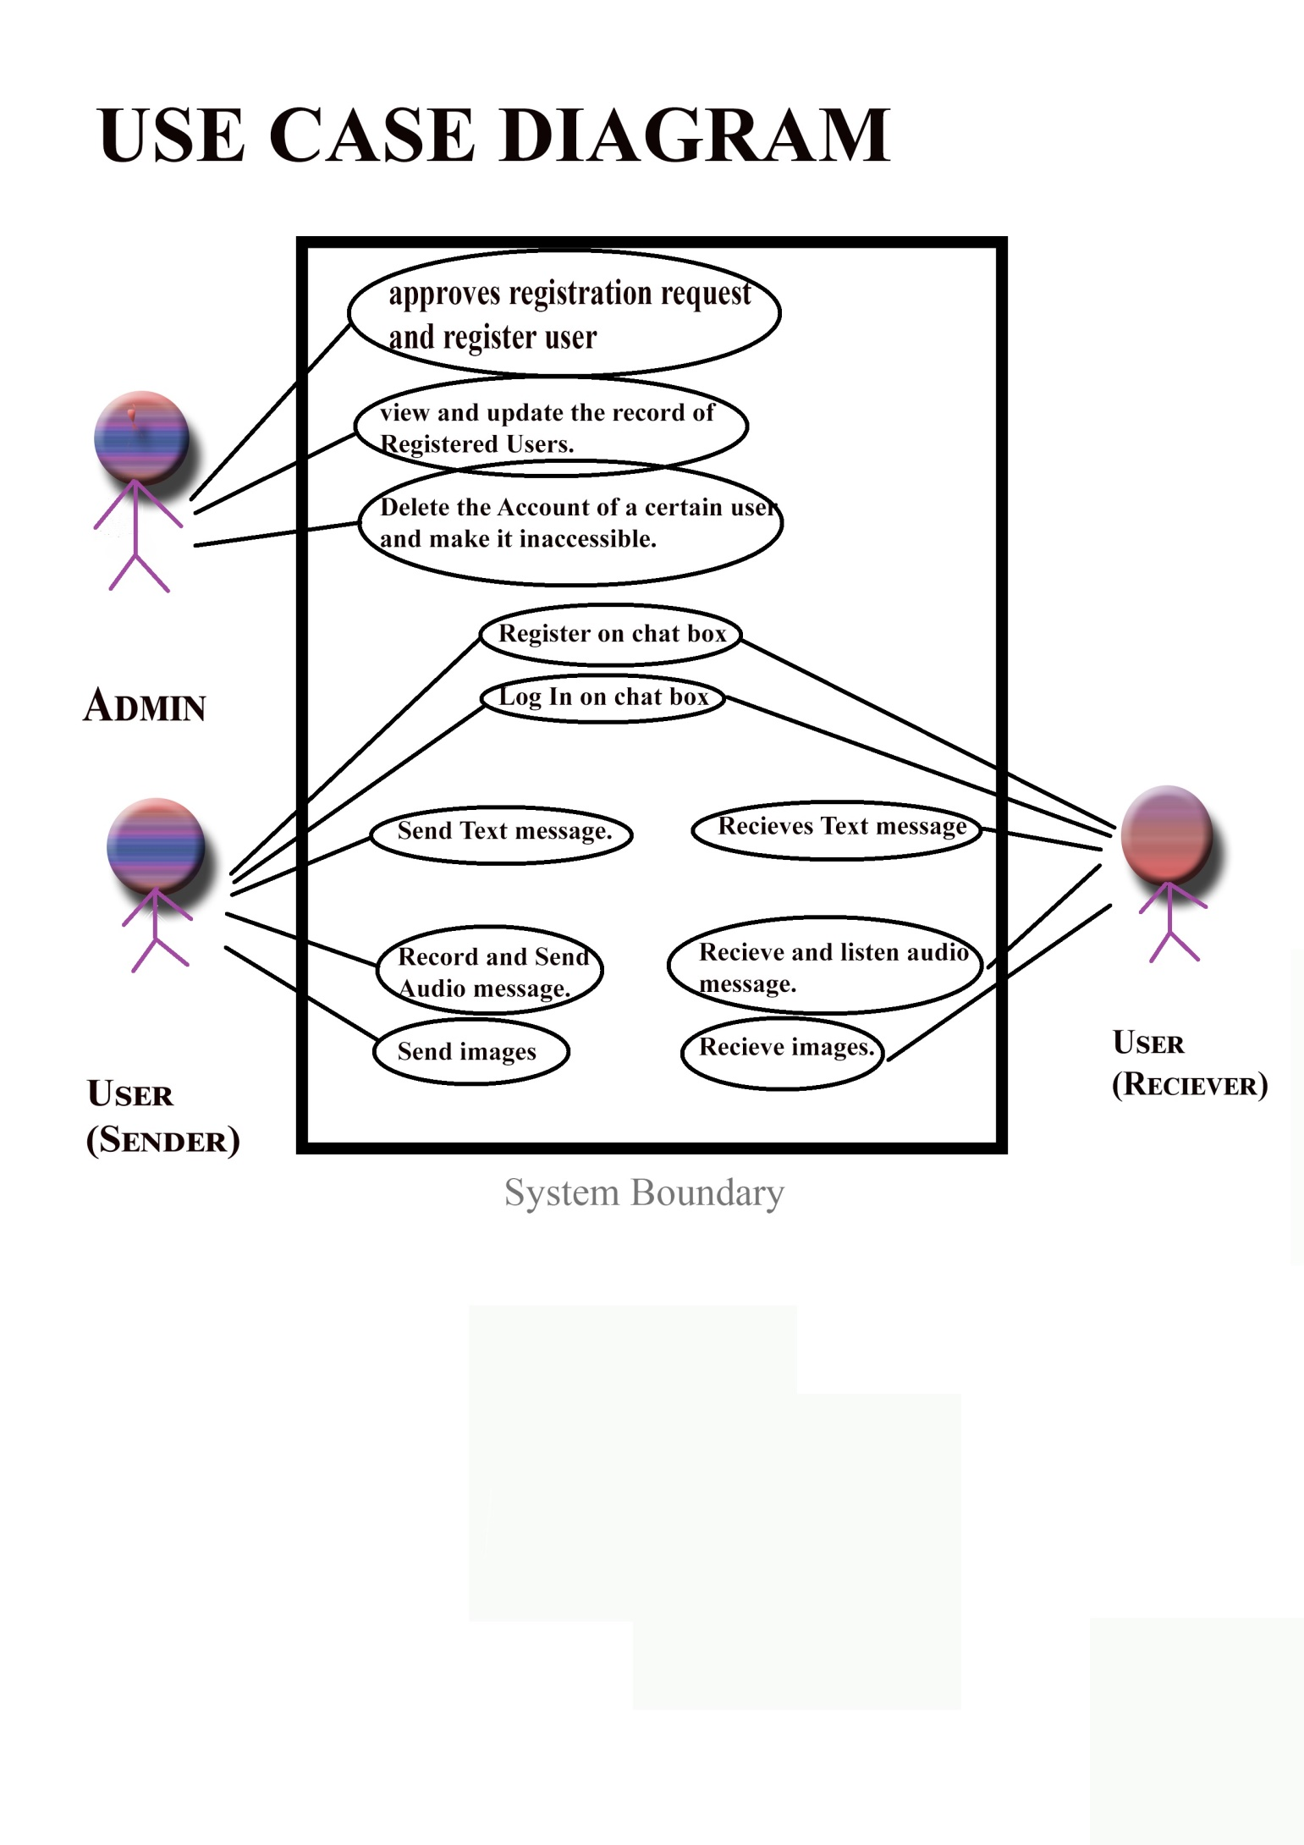

## System Flow Diagram

## Wire Frames of System

These are some major wire Frames of system on which the interface of system will work but they can be modified and updated further on according to the requirement.

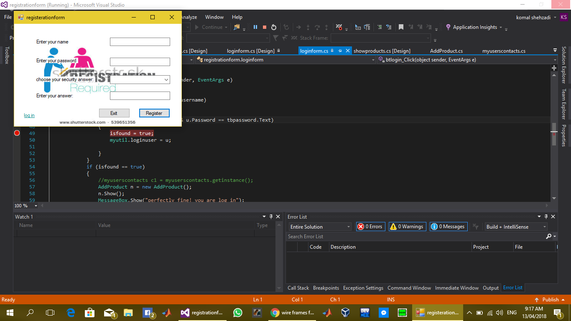

Here is the registration form of our chat box in which some information will be asked from user so that in future his account can be secured and back up can be done in case of any problem. There is a link label “log in” in the form if user already have an account he can directly log in by clicking on that label.

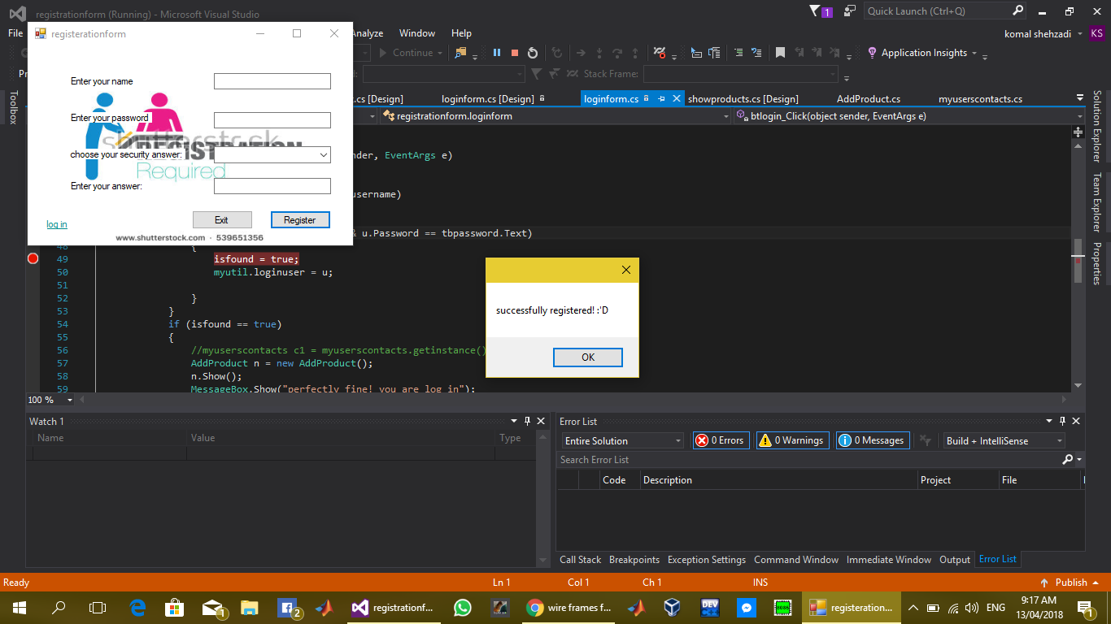

When user is registered successfully this dialog box will appear to give confirmation.

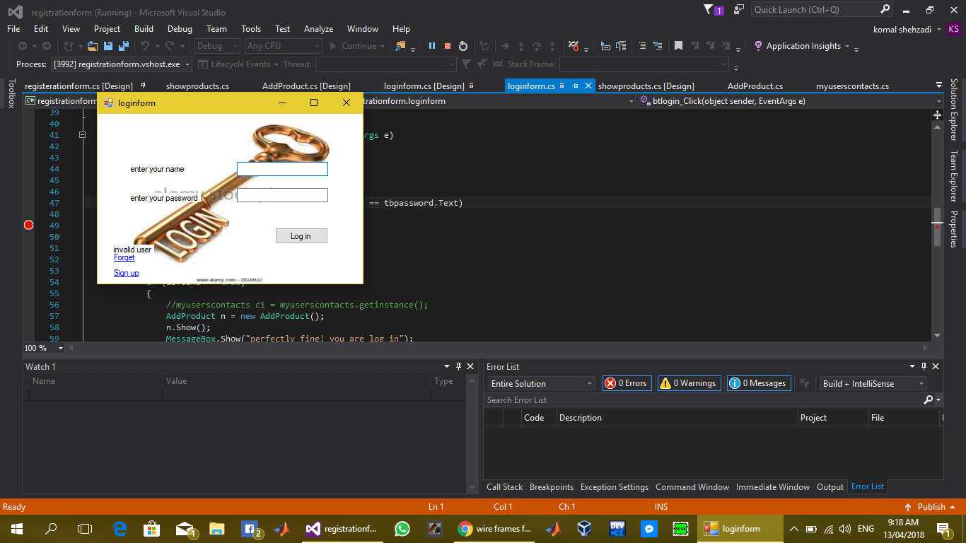

Here is the log in form of our chat box user can log in “Or Sunao” by simply adding his name and password registered user can also go back on registration form by clicking on “Sign up” link label. User can also change his password by clicking on “Forget” link label by providing some additional information taken in registration form. Now user can Log in.

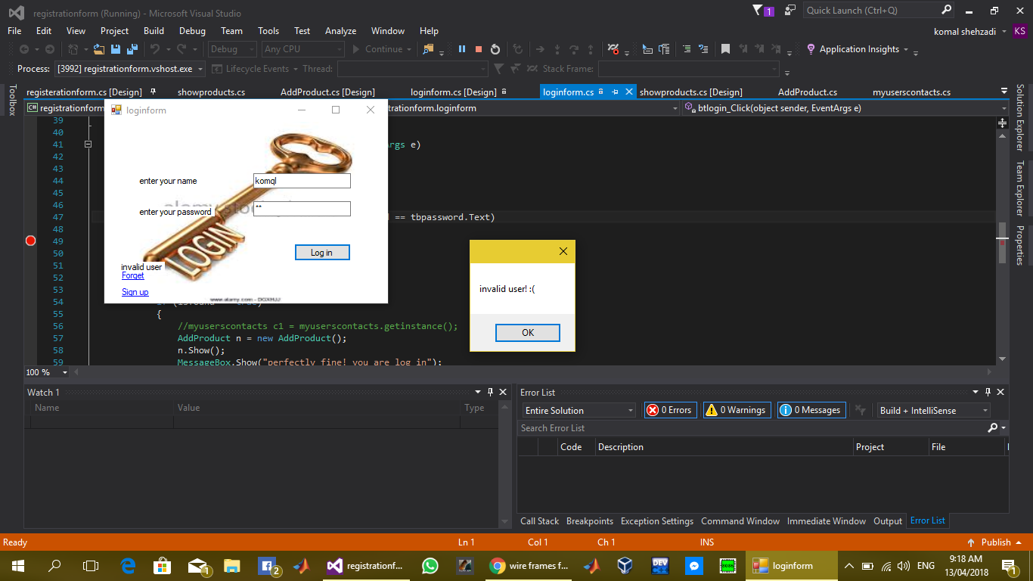

In case of wrong name or password this dialog box will appear on screen.

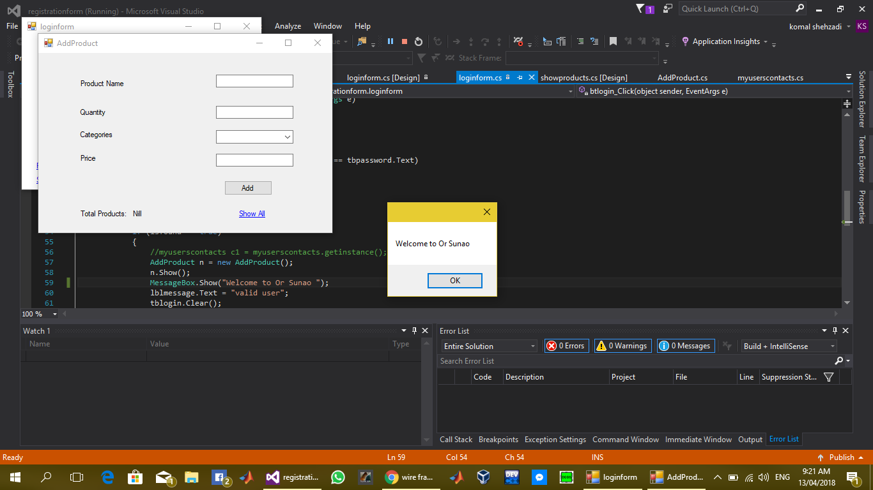

When a authorized user log in on the chat box this dialog box will appear on the screen.

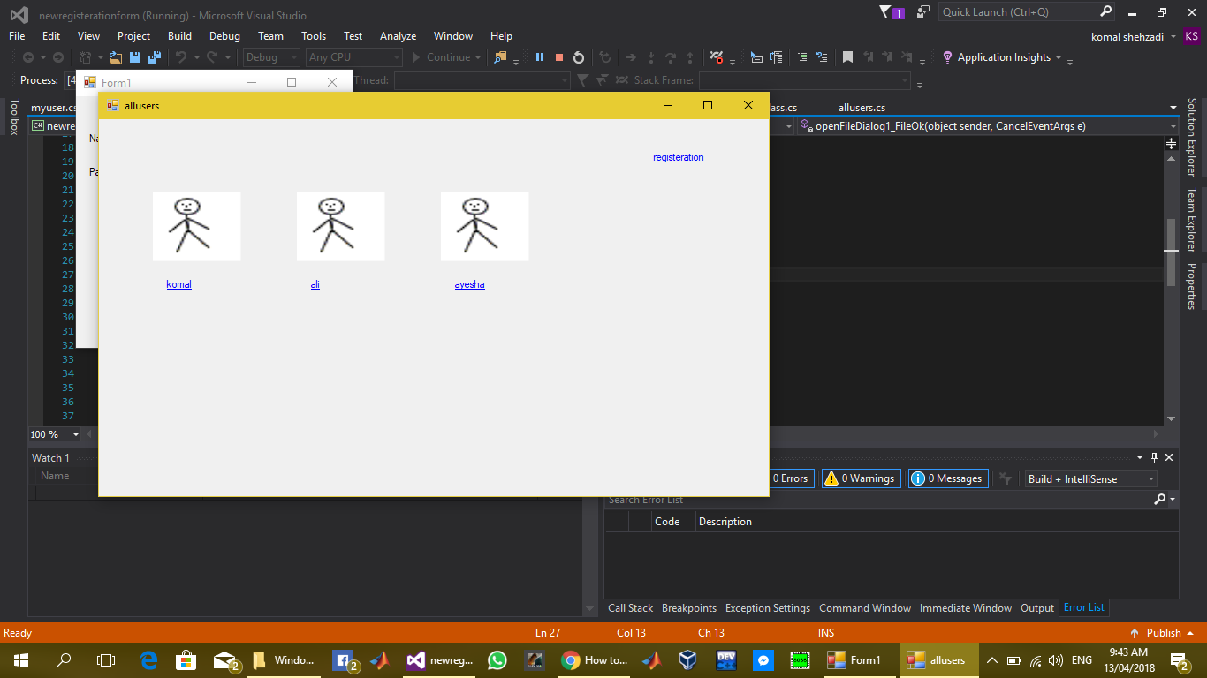

When user log in this form will be shown in which all the users previously entered in chat box will appear with their name now user can connect to anyone by clicking on his/her profile. If User grant him access, they can chat with each other on “Or Sunao”.

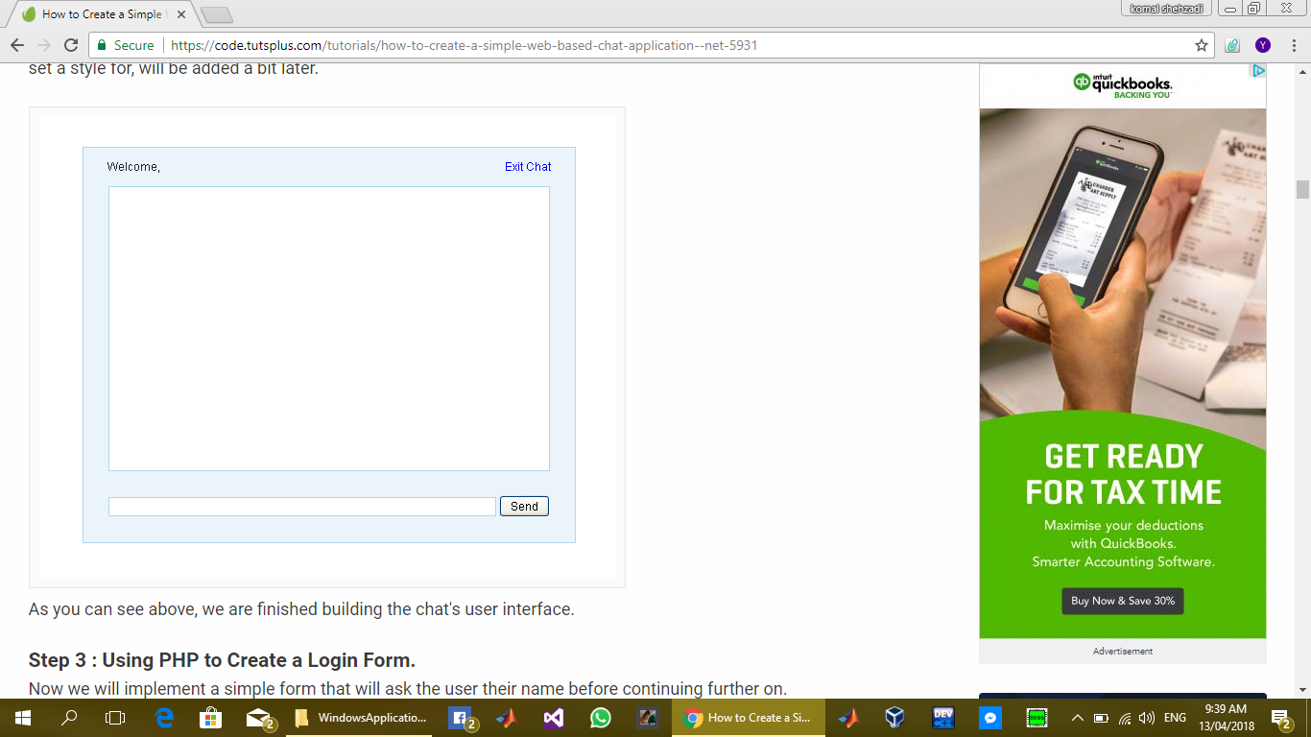

The layout of “Or Sunao” chat box will be like this. “Send” button will contain three options for text, image or audio user can exit the chat by clicking on “Exit Chat” link label placed on top on the right side of form.

## Domain Model

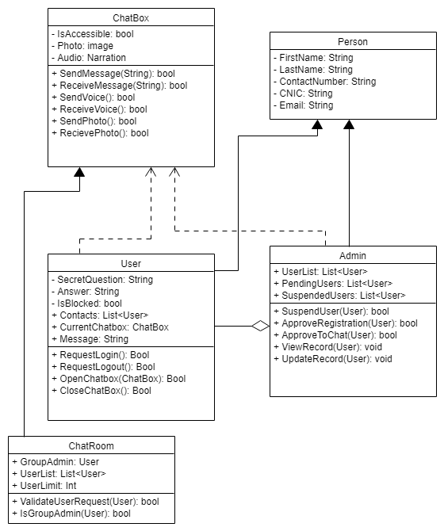

## Back Locks:

Back locks are the weaknesses in a system.

There are few weaknesses in our system regarding security and connection.

### Weakness in security:

If a person somehow gets the password of any other user he/she can log in to user’s account and can send and receive messages.

### Weakness in connection:

The weakness in connection is that both the users should connect with same internet network.

## Sprint Plan:

Sprint plan is actually the time and cost of the each module in system or service that is to be developed.

1. The time to develop service is approximately two days.
2. The time to develop the forms (registration and login forms) is approximately a day.
3. The time to develop the develop chat plan can take up to 4 to 5 days approximately.

This is the approximate time in which we thought we can implement the chatting system. Since this is not a company or any business project so we may not be able to calculate the cost for this.

## Development story:

1. We will make a service for the chatting between two persons.
2. The service will provide the registration, login and chatting.
3. First there will be formation of registration form.
4. All the record of users chat will be stored in the system.
5. Then a login form will be formed.

After that a there will be formation of chat plan